Sort Sentence Alphabetically
Python.file:

Screenshot:

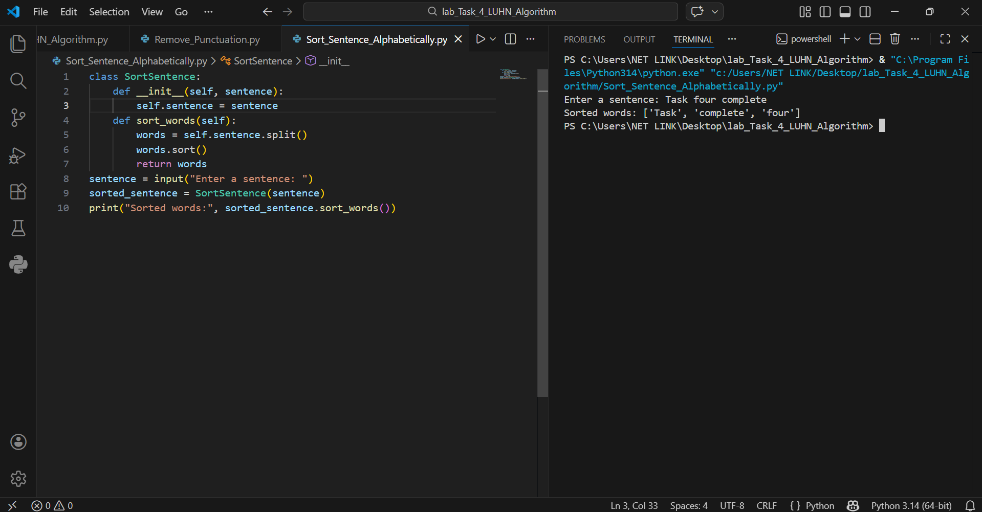

Main Components
• Class: sortsentence
• Attribute: self.sentence(stores input sentence)
• Method: sort_words() sorts the words
• Function Used: split() and sort()
• Logic: Alphabetical sorting of words

How the Program Works

1. Start
• The program asks the user to enter a sentence.
• An object of the sortsentenceclass is created.
• The input sentence is stored in self.sentence.

2. Split Sentence into Words
• The sentence is divided into individual words using split().
• This creates a list of words.

3. Sorting Words
• The list of words is sorted using the sort()method.
• Words are arranged in alphabetical order.

4. Return Sorted Words
• The sorted list is returned from the sort_words() method.
• No punctuation or formatting changes are applied.

